USE SalesOrdersExample;

SELECT \* FROM Customers WHERE CustState='WA';

Include only customers who live in Washington state (WA)

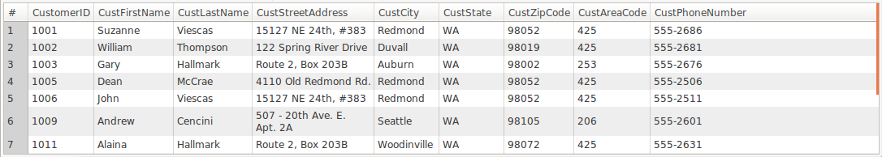

SELECT \* FROM Customers WHERE CustState='WA' OR CustState='OR';

Include customers who live in Oregon and Washington

